Press release: 6/16/04
For Immediate Release
Contact: Daniel and Halana Rosenfield
daniel.rosenfield@mamash.com
www.chanaliora.com

Worldwide: Shabbat Chessed – Sabbath of Kindness

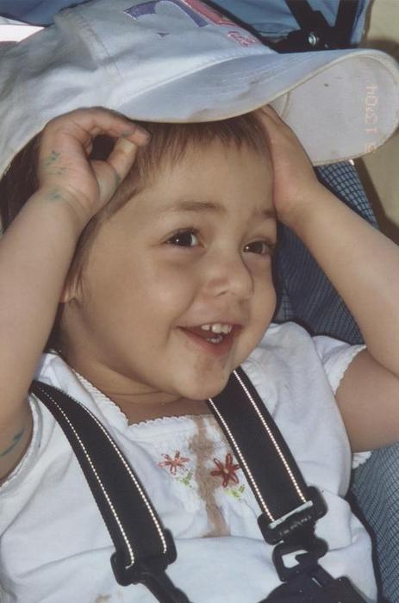
Congregation/ Camp/ ________________is pleased to announce that we will participate in the first annual Worldwide Shabbat Chessed - Sabbath of Kindness. Congregation ______________is located at ____________________. Our telephone number is __________________. For more information please contact Rabbi ___________________________.

Chana Liora Rosenfield, of Ramat Bet Shemesh, Israel, was just three years old when she succumbed to Cancer after a heroic and inspiring struggle. Chani was the first child in her family to be born in Israel after her parents made Aliya 4 years ago from New York. Chani was diagnosed with stage IV Neuroblastoma at Hadassa Hospital in Jerusalem and later continued treatment in Memorial Sloan Kettering in NY. She underwent many rounds of chemotherapy, radiation, surgery, antibody treatment, etc., including various hospital stays. Chani passed away on June 1, 12th of Sivan.

In commemoration of the shloshim (30 days since the passing) of their daughter Chana Liora Rosenfield, her parents, Daniel and Halana have launched the first annual Worldwide Shabbat Chessed or Sabbath of Kindness to take place on Shabbat Parashat Balak, 14th of Tamuz 5764, July 3, 2004. On the designated weekend (Fri.-Sun. July 2-4th), congregations, summer camps, youth groups and individuals are being asked to pay special attention to doing acts of kindness as well initiate programs that help others do acts of kindness. Additionally, congregational Rabbis are being asked to use their sermon time that Shabbat to speak about the importance of doing acts of kindness.
The idea for this program was spurred by all of the acts of kindness, Torah study and charity that people took on as part of a worldwide effort on behalf of Chani.

Descriptions of Chani enjoying every moment of life and teaching others the importance of chessed, even while she suffered, left an indelible mark in the hearts and minds of
anyone who knew her.

Her parents remember her not only hooked up to an IV pole - but RIDING the IV pole around the hospital with a big smile, making all of the children and parents laugh and
bringing some joy to the other patients and their families.

Chani taught others to appreciate every moment in life. She was so good-natured and happy. On one occasion when she was only 1 and a half she had to have an IV inserted in the middle of the night. After many tries at stabbing and jabbing to get the IV in and much crying, Chani turned up to the nurse and gave her a kiss. This is who Chana Liora
Rosenfield was, she took everything in stride and with a smile.

Arranging hospital visits, sending cards to American and Israeli soldiers, helping elderly home-bound with their shopping, running a local toy drive for sick children, and providing
help to families in need are just a few of the ideas that Shabbat Chessed is promoting. Numerous program ideas, tools, and Jewish sources connected to Kindness are available on the website that was set up when Chani was first diagnosed:
www.chanaliora.com.

Daniel and Halana Rosenfield, noted that: "Chani inspired people around the world to greater heights in prayer, chessed and unity. In her short life, Chani accomplished
more than many do in an entire lifetime." Daniel Rosenfield urges us to remember that : "the world is a wondrous place, and you never know the impact of your actions."

Ultimately the Worldwide Shabbat Chessed is a mitzvah campaign. It is fitting to honor Chana Liora Rosenfield in this way as she personified a love of mitzvoth. Daniel
Rosenfiled said in his eulogy for his daughter that:
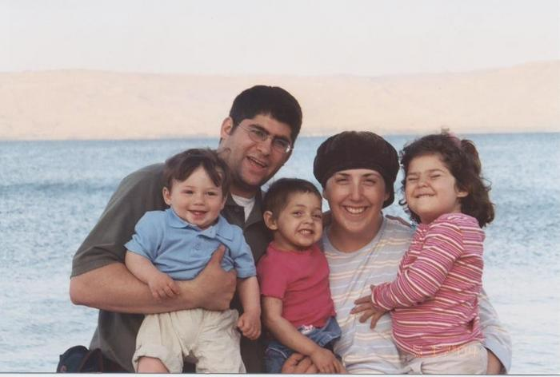
“Chani was my mitzvah girl. From a young age she loved kissing mezuzot, going to shul with me and kissing the torah and aron kodesh, having a lot and a little of Kiddush as
she liked to say, davening with me on the way home from shul, she was the one to put the Shabbos candles in, jumping on her bed as she would excitedly say Shema.”

In her memory and on behalf of so many other sick children, the Worldwide Shabbat Chessed has been launched and you are invited and urged to join.

For more information and resources please go to www.chanaliora.com

