בס"ד
Join the

WORLDWIDE

SHABBAT CHESED

Parashat Balak
July 2-4th
13-15th of Tamuz

(FILL IN THIS SPACE WITH YOUR SPECIFIC COMMUNITY INFO & PLANNED ACTIVITIES)

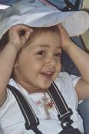

FOR MORE INFORMATION AND RESOURCES, PLEASE GO TO:

WWW.CHANALIORA.COM

In commemoration of the shloshim (30 days since the passing) of their 3-year old daughter Chana Liora Rosenfield, her parents, Daniel and Halana, have launched the first annual Worldwide Shabbat Chessed or Sabbath of Kindness. Chani was a special young girl who brought much joy with her special smile and laugh, and inspired many around the world to great hights of Torah, tefilla, chesed and unity.

